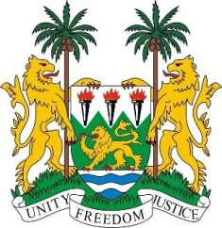
SIERRA LEONE

27th Session of the UPR

UNITED KINGDOM OF GREAT BRITAIN & NORTHERN IRELAND

Statement by Ambassador Yvette Stevens

4 May 2017

Mr President,

Sierra Leone welcomes the distinguished delegation from United Kingdom of Great Britain and Northern Ireland to this review cycle and thanks them for today’s presentation and the efforts to address human rights generally.

My delegation commends the comprehensive efforts to effectively tackle domestic violence in all its forms, through the Modern Slave Act of 2015 and various enforcement strategies.

Similarly noteworthy are the various measures to comprehensively address the trafficking of children through national legislation, the Child Trafficking Protection Fund and through the child protection system.

My delegation applauds the efforts of the UK government to address social issues and encourages that these are not negatively affected by budget cuts.

Sierra Leone furthermore thanks the UK for the assistance provided during the Ebola crisis, as well as for their continued commitment to allocating 0.7% of GNI to official development assistance.

Recommendations:

- Sign and accede to the ICPPED.
- Develop a plan of action to implement the activities of the Decade of People of African Descent, which would, inter alia, address concerns of racial profiling of people of African Descent.
- Develop a comprehensive strategy to address inequalities experienced by ethnic minorities.
- Re-evaluate the impact of welfare reforms on the disabled and vulnerable groups.

Finally, Sierra Leone wishes the United Kingdom of Great Britain and Northern Ireland every success in this third review cycle.

Thank you, Mr President.

